**KEGIATAN PRAKTIKUM**

**Percobaan 1**

1. Buat kombinasi gerbang logika sebagaimana pada gambar di bawah ini!

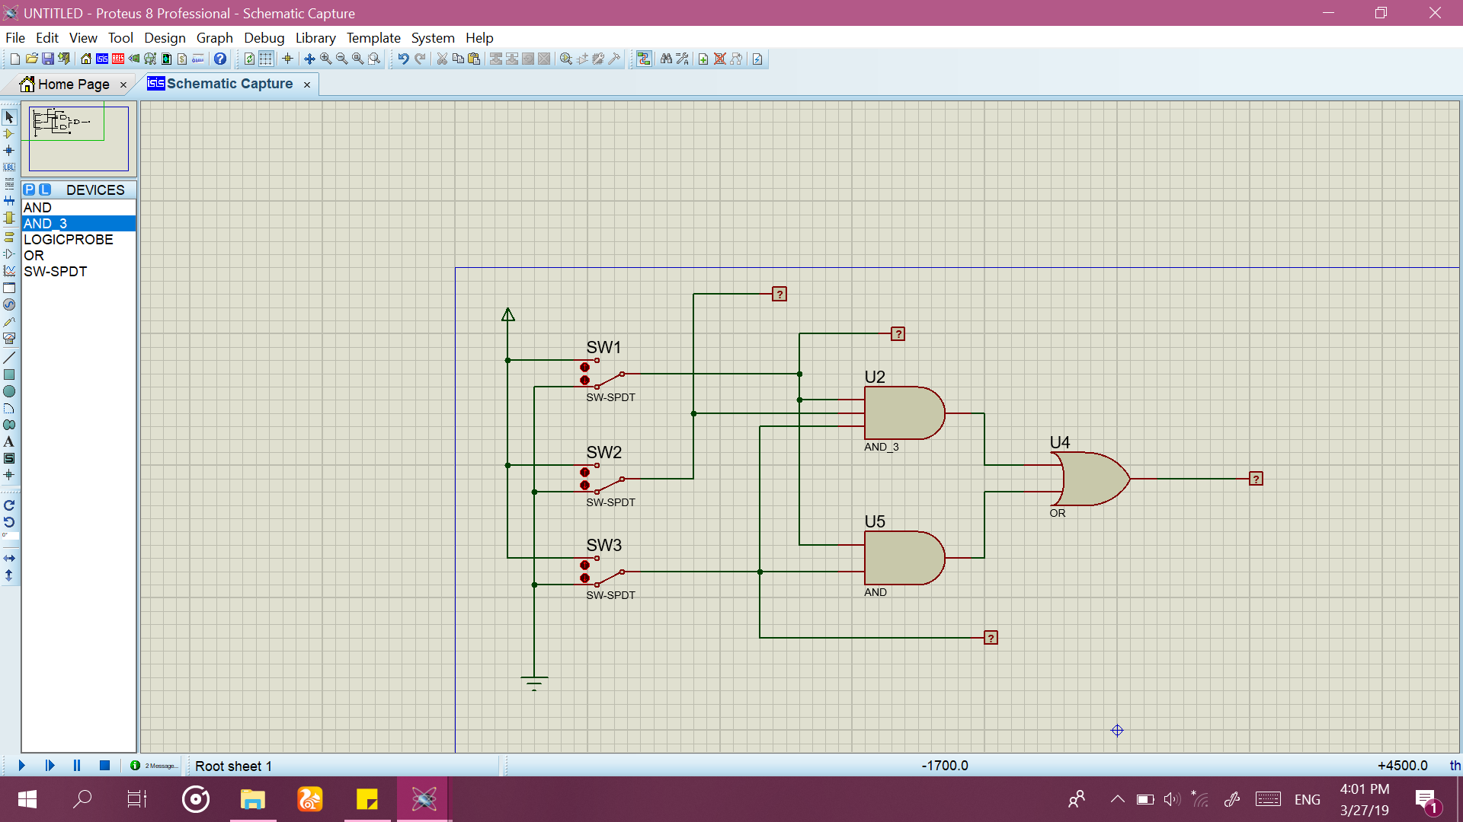

1. Fungsi Boolean : **F = ABC + AC**
2. Isi titik-titik dalam tabel!

|  |  |  |  |
| --- | --- | --- | --- |
| A | B | C | F |
| 0 | 0 | 0 | 0 |
| 1 | 0 | 0 | 0 |
| 0 | 1 | 0 | 0 |
| 1 | 1 | 0 | 0 |
| 0 | 0 | 1 | 0 |
| 1 | 0 | 1 | 1 |
| 0 | 1 | 1 | 0 |
| 1 | 1 | 1 | 1 |

1. Isi titik-titik dalam karnaugh map

|  |  |  |  |  |  |
| --- | --- | --- | --- | --- | --- |
|  | | AB | | | |
| 0 0 | 0 1 | 1 1 | 1 0 |
| C | 0 |  |  |  |  |
| 1 |  |  | 1 | 1 |

1. Sederhanakan Fungsi Boolean berdasarkan karnaugh map:

**F** = AC

1. Buat kombinasi gerbang logika berdasarkan fungsi boolean baru anda!

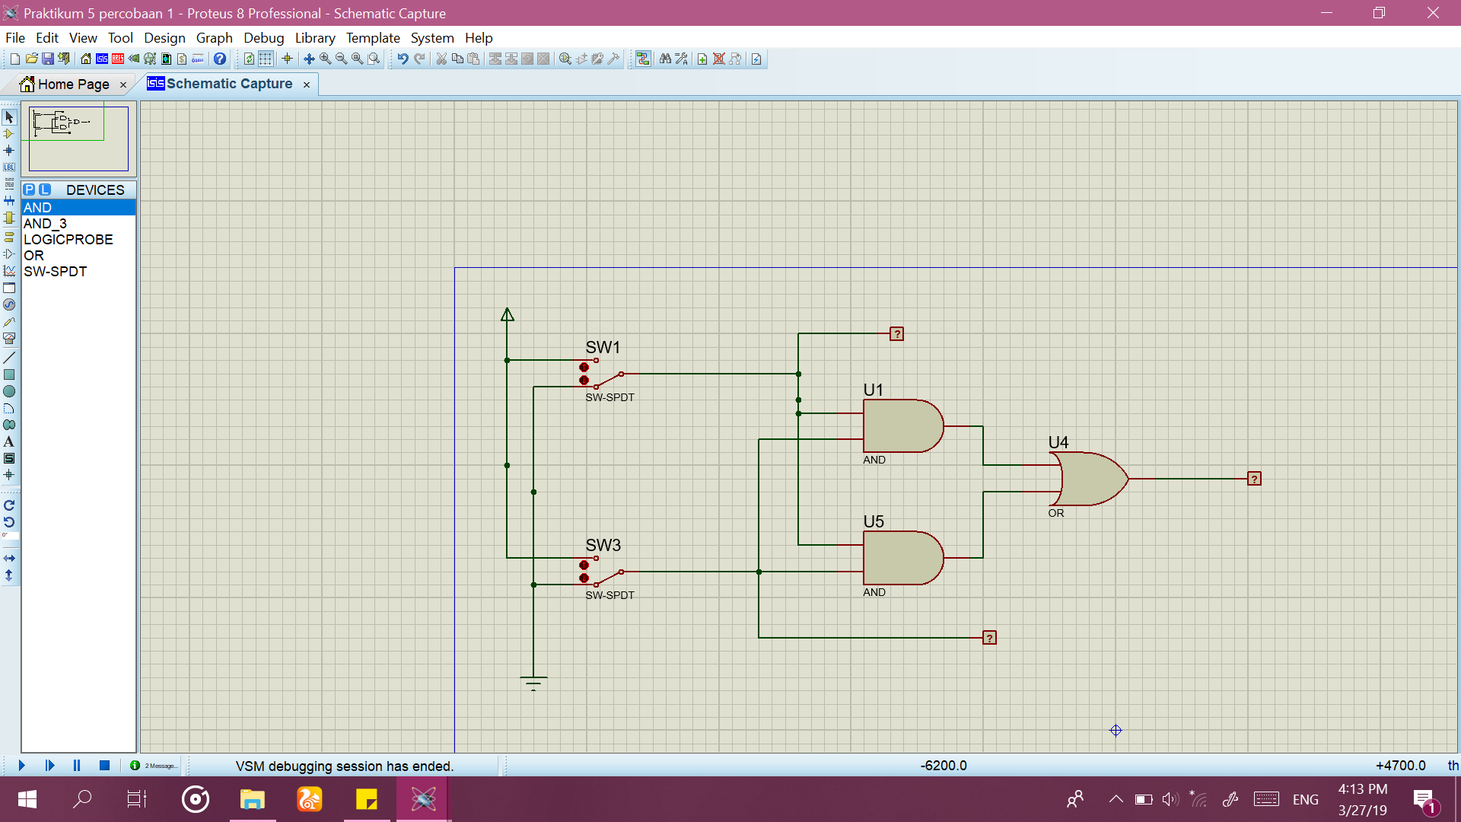

**Percobaan 2**

1. Buat kombinasi gerbang logika sebagaimana pada gambar!

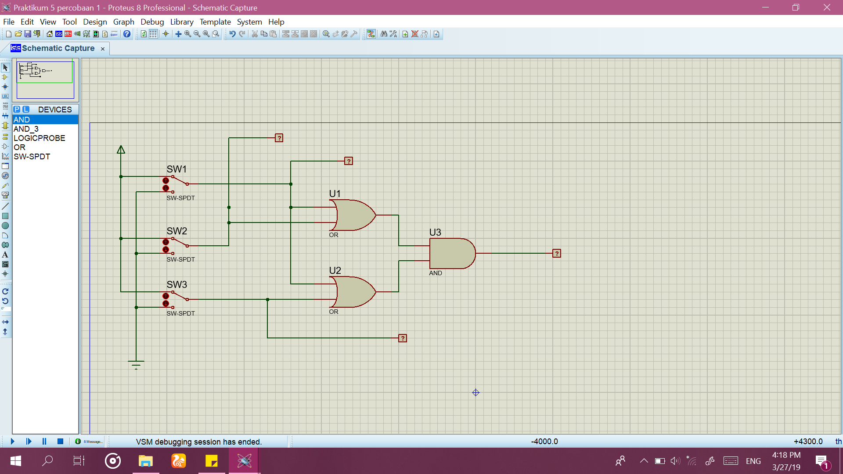

1. Fungsi Boolean : **F = (A + B) . (A + C)**
2. Isi titik-titik dalam tabel!

|  |  |  |  |
| --- | --- | --- | --- |
| A | B | C | F |
| 0 | 0 | 0 | 0 |
| 1 | 0 | 0 | 1 |
| 0 | 1 | 0 | 0 |
| 1 | 1 | 0 | 1 |
| 0 | 0 | 1 | 0 |
| 1 | 0 | 1 | 1 |
| 0 | 1 | 1 | 1 |
| 1 | 1 | 1 | 1 |

1. Isi titik-titik dalam karnaugh map

|  |  |  |  |  |  |
| --- | --- | --- | --- | --- | --- |
|  | | AB | | | |
| 0 0 | 0 1 | 1 1 | 1 0 |
| C | 0 |  |  | 1 | 1 |
| 1 |  | 1 | 1 | 1 |

1. Sederhanakan Fungsi Boolean berdasarkan karnaugh map:

**F** = A + BC

1. Buat kombinasi gerbang logika berdasarkan fungsi boolean baru anda!

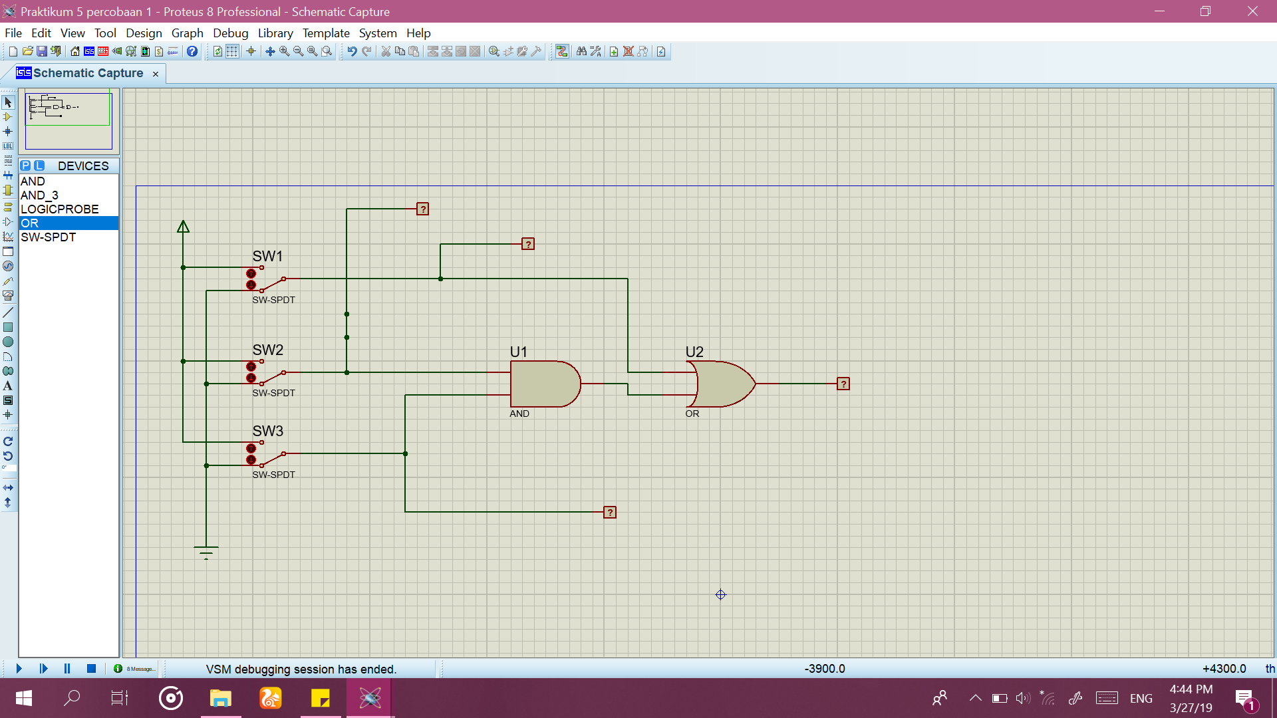

**Percobaan 3**

1. Buat kombinasi gerbang logika sebagaimana pada gambar!

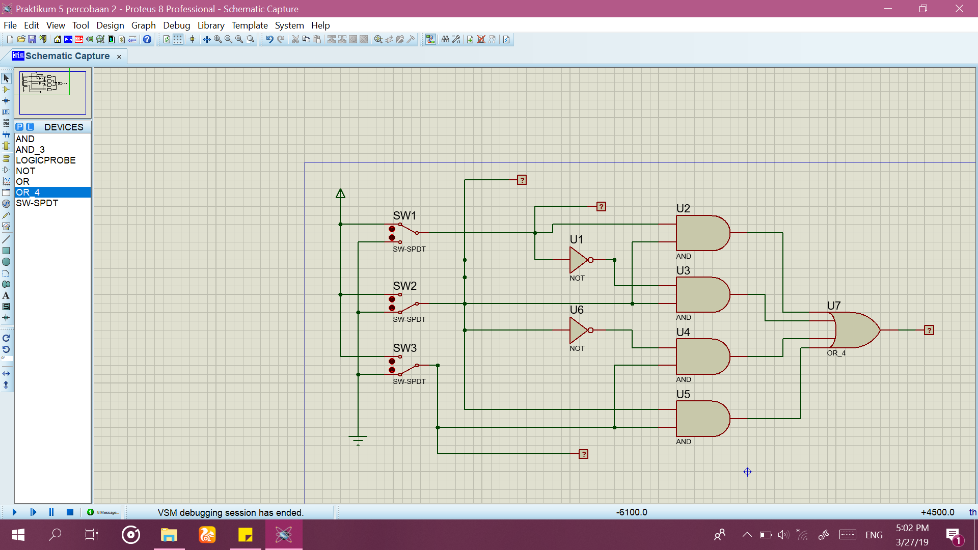

1. Fungsi Boolean : **F = AB + A’B + B’C + BC**
2. Isi titik-titik dalam tabel!

|  |  |  |  |
| --- | --- | --- | --- |
| A | B | C | F |
| 0 | 0 | 0 | 0 |
| 1 | 0 | 0 | 0 |
| 0 | 1 | 0 | 1 |
| 1 | 1 | 0 | 1 |
| 0 | 0 | 1 | 1 |
| 1 | 0 | 1 | 1 |
| 0 | 1 | 1 | 1 |
| 1 | 1 | 1 | 1 |

1. Isi titik-titik dalam karnaugh map

|  |  |  |  |  |  |
| --- | --- | --- | --- | --- | --- |
|  | | AB | | | |
| 0 0 | 0 1 | 1 1 | 1 0 |
| C | 0 |  | 1 | 1 |  |
| 1 | 1 | 1 | 1 | 1 |

1. Sederhanakan Fungsi Boolean berdasarkan karnaugh map:

**F** = B + C

1. Buat kombinasi gerbang logika berdasarkan fungsi boolean baru anda!

